

INSTALLATION MANUAL

Table of Contents

- Applicable Version………………..…....……………………………….……1
- Installation....……………..…………….……….……………………………..2
- Configuring Worldline………………..………………………………….……4

Applicable versions

Applications | Versions
PHP | 5.6.x to 7.0.x
Opencart | 1.x.x

Installation and Upgrades

Please follow the given steps to install and run the Worldline Payment Gateway module
1. Copy all files/folders recursively(admin & catalog) to opencart installation directory
2. Go to Extensions->Payments and install the Worldline gateway extension.
3. Then under Navigations go to System->Users->User Groups
4. Edit Top Administrator,
Under Access Permission select payment/reconciliation and payment/verification.
Under Modify Permission select payment/reconciliation and payment/verification

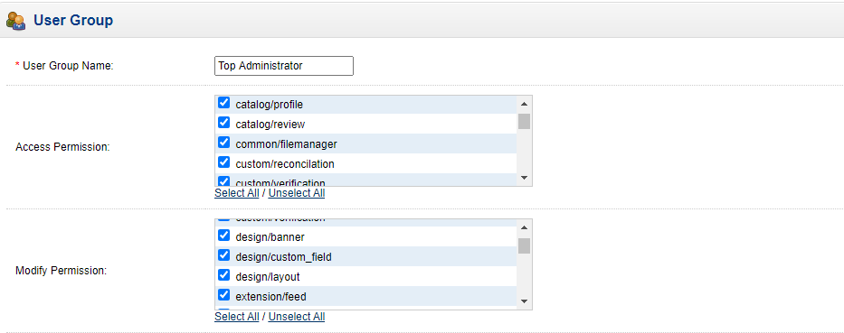

- Click on save

Update Plugin
1. Under Navigation Go to Extensions->Extensions select type as payments and Uninstall Worldline
2. After the successful uninstallation, install the updated Worldline package as mentioned above.

Configuring Worldline

- Go-to go to Extensions choose type as payments
- Scroll down. You will see Worldline, Edit it
- Configure it as below:

Column Name | Description
Enabled | Click on the checkbox in order to Enable Worldline
Merchant Code | Enter Merchant Code
Salt | Enter Salt.
Payment Type | For Test mode Select ‘Test’ and for Live mode select ‘Live’
Merchant Scheme Code | Enter Scheme Code

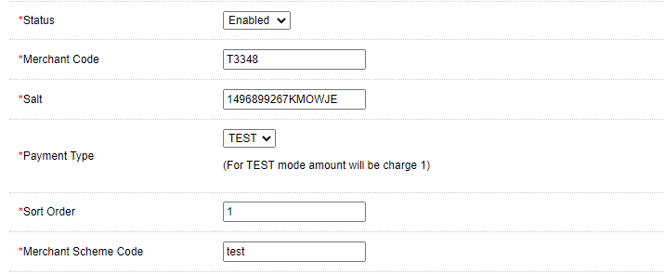
- Now click on “Save Changes” on top- right corner.
- Worldline Payment Gateway is now configured & ready to use.
Advanced Configuration
There are also some advanced configuration options you may consider as shown below:

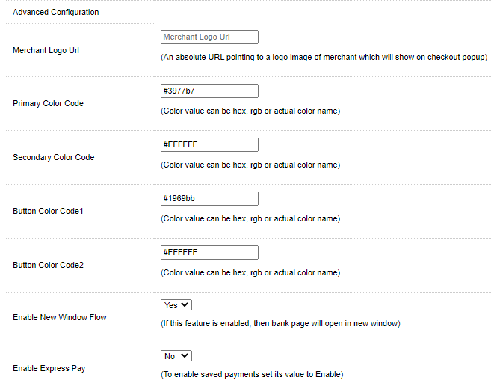

Features List

Dual verification of response
We are validating responses with a hash value and call again Payment Gateway for dual verification from the payment gateway before updating to the order status.

Reconciliation
Merchants can update the pending status of the order automatically if the payments are successful. This page can be found under Extensions- > Payment-> Configure Worldline Gateway->Reconcilation
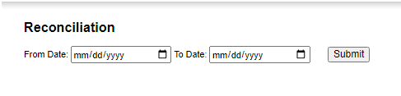

Logs request and response
Daily new file creates for the logs request and response from the server for future reference.

S2S Verification
If we do not receive any response from the payment gateway then after 30 mins, we will get a response from the server and based on the response it will update order status.
To configure S2S URL, contact prod team.

S2S url format : hostname/index.php?route=payment/Worldline/s2sverification
S2S url example : http://example.com/index.php?route=payment/Worldline/s2sverification

MCG
It supports the multi currency like USD, GBP, SGD and a lot more.

Worldline Offline Verification

Merchants can verify the status of their payment by using the Payment Verification page. The payment verification page can be found under Extensions- >Payment-> Configure Worldline Gateway->Worldline Offline Verification
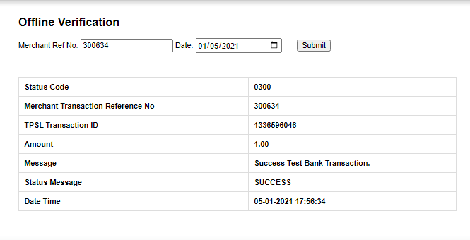

Refund
Merchants should be able to process the refund online for the order whose payment has been done via Worldline.
To refund an order View the particular order you want to refund. Under PaymentDetails select Worldline Refund.
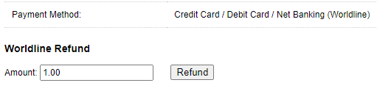

Embed Payment Gateway

After enabling this setting, payment gateway displays like embedded on the page instead of pop-up so user experience would be good.

Documentation link
https://www.tecprocesssolution.com/proto/p2m/client/salt-based-documentation.htm#online

